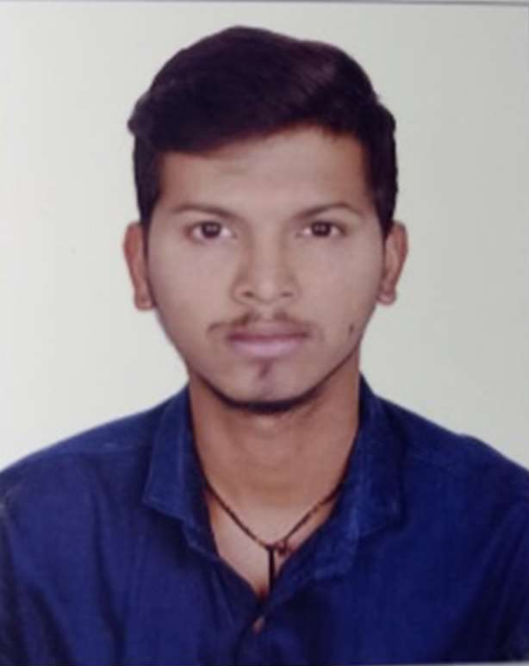SANDESH A PALEKAR

# COMPUTER ENGINEER

OBJECTIVE

To secure a position where I can efficiently contribute my skills and abilities to the growth of the orginization and bulid my professional career.

# CONTACT

Santacruz (E), Mumbai



# TECHNICAL SKILLS

PROJECT DETAILS

## Cops

(Hindusthan Microfinance Pvt Ltd)

Cops (Customer Onboarding Processing System) Applicantion is a part of Hindusthan Microfinance Pvt Ltd. is one of the leading private sector financial services company in India that offers financial services to low income people.. This application mainly used for given LOAN and also there is CRMS software.

**Technology**: C#, Dotnet Core Web API (for backend) , MS SQL Server

#### Roles and Responsibility:

* + Application development as per bussiness need.

## Propelor

Languages Tools & Technologies

C#, SQL, TypeScript and HTML, Go Language.

Visual Studio, MS SQL Server, pgAdmin, .Net Framwork 6, MVC, .Net Core, ADO.NET,

Angular 13, Ajax, Web Sevices, Entity Framework Core.

### (Synoris Information Systems Pvt Ltd)

Propelor is an Digital-first solution for global logistics is export and import shipments , hassle-free freight and logistics services, while creating sustainable solutions . This application mainly used for **Container Booking System** for import and export by Ocean and land transportation. Provides you the real-time tracking services of vessels and containers

**Technology**: C#, Dotnet Core Web API(for backend) with Entity Framework, PostgreSQL, Elasticsearch

Database MS SQL Server, Oracle SQL Developer, PostgreSQL server

Operating Systems Windows

#### Roles and Responsibility:

* + Application development and maintenance as per bussiness need.

# EXPERIENCE

* 1.4 years at Clover Infotech as Backend Developer.
* 2 months at Synoris Information Systems Pvt Ltd.
* Currently Working at APPIC Mobile as Backend Developer.

# ACHIEVEMENTS

* Participation in **Formula Student UK at London** as team member of Team MH08 Racing on July 2019
* Participation in **SUPRA SAEINDIA** at Greater Noida as team member of Team MH08 Racing on July 2018

# STRENGTHS

## NYSA

### (Client: ICICI Lombard General Insurance)

Nysa Application is a part of ICICI Lombard General Insurance Company Ltd. is one of the leading private sector general insurance company in India offering insurance coverage for motor.This Application mainly used for creating Insurance against Motor Policy by Agent. There are many modules in Motor application mainly Two Wheeler, Four Wheeler, Electric Bike, GCV and miscellaneous etc. Policies can be purchased and renewed online as well. Immediate issuance of policy copy online.

**Technology**: C#, Dotnet Core Web API, Oracle SQL Developer

#### Roles and Responsibility:

* + Application development and maintenance as per bussiness need
  + Performance optimization of web applications
* Leadership
* Quick learner
* Honesty
* Dedication
* Teamwork

# CERTIFICATION

* Python certification from DCO Academy
* PHP and MYSQL at DPERS, Kudal
* Android app development from Dalvik Apps

# HOBBIES

Driving, motorsports, learning new things

# EDUCATION

* RMCET (Computer Engineering) Mumbai University

May 2020

* Shri G.P.M Degree College

HSC – Maharastra State Board March 2016

* St. Lawerence high School

SSC – Maharashtra State Board March 2014

6.18

CGPA

55%

70%

Declaration: I hereby declare that the above-mentioned information is true to the best of my knowledge and belief.

### SANDESH ASHOK PALEKAR

Place: Mumbai